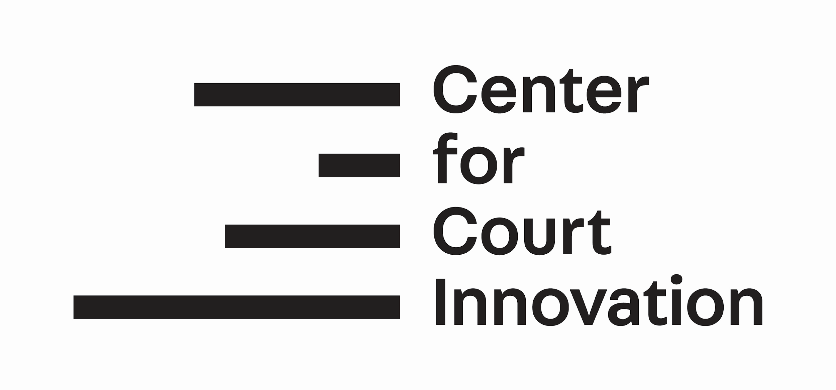
Innovative Justice Study Tour
New York Itinerary
Sunday, 23 June 2019 - Friday, 28 June 2019

For all court visits, please allow extra time for security screening.

Sunday 23 June 2019
6:30 pm | Welcome Dinner | Speedy Romeo  63 Clinton St.,  New York, NY 10002

Monday 24 June 2019
9:00 am -12 pm | Manhattan Criminal Court | New York Criminal Court  100 Centre Street  New York, NY 10013
12:00 pm - 1:30pm | Lunch Break | Manhattan, NY
1:30 pm - 4:00 pm | Introduction to the Center for Court Innovation | CCI Headquarters  520 8th Avenue  New York, NY 10018
4:00 pm - 6:00 pm | After Rikers  Film Screening and Q&A | Hunter College  Manhattan, NY

Tuesday 25 June 2019
9:30 am - 1:30 pm | Red Hook Community Justice Center | Red Hook, Brooklyn  88 Visitation Pl, Brooklyn, NY 11231
1:30 pm - 2:30 pm | Lunch Break | Red Hook, Brooklyn
2:30 pm - 3:30 pm | Travel between Red Hook and Brownsville | Travel
3:30 pm - 5:00 pm | Brownsville Community Justice Center | Brownsville, Brooklyn  50 Belmont Avenue,  Brooklyn, NY 11212

Wednesday 26 June 2019
9:30 am - 2:30 pm | Newark Community Solutions (NCS) | Newark, New Jersey  31 Green Street,  Newark, NJ 07102
3:00 pm - 5:00 pm | Express Newark | Express Newark  54 Haley Street  Second Floor  Newark, NJ 07102

Thursday 27 June 2019
9:15 am - 9:45 am | Bronx Hall of Justice | Bronx Hall of Justice  265 East 161st Street  Bronx, NY 10451
12:00 pm - 1:00 pm | Lunch Break | Bronx
1:00 pm - 4:00 pm | Bronx Community Solutions | Bronx Criminal Court  215 East 161st Street  Bronx, NY 10451

Friday 28 June 2019
9:00 am - 11:00 am | Facilitated debrief | CCI Headquarters  10th Floor Conference Room
12:00 pm | Farewell lunch | TBA

